|  |  |  |  |  |
| --- | --- | --- | --- | --- |
| React | Lectures | 1 | 2 | 3 |
|  | 1 |  | Done |  |
|  | 2 |  | Done |  |
|  | 3 |  | Done |  |
|  | 4 |  | Done |  |
|  | 5#5 File and folder structure |  | Done |  |
|  |  |  |  |  |
|  |  |  |  |  |
|  |  |  |  |  |
|  |  |  |  |  |
|  |  |  |  |  |
|  |  |  |  |  |

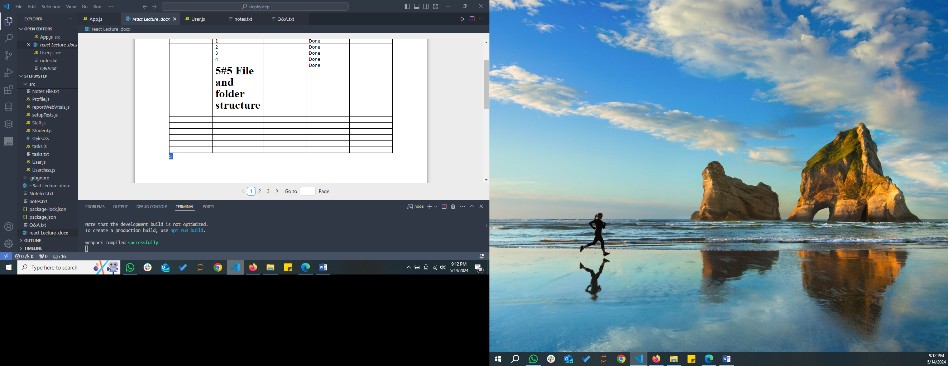

http://localhost:3000/